A
Real-Time Research Project On
STUDENT PERFORMANCE PREDICTOR & TRACKER
(Submitted in partial fulfillment of the requirements for the award of Degree)

BACHELOR OF TECHNOLOGY
In

COMPUTER SCIENCE AND ENGINEERING
By

M. Akshaya (217R1A05W4)
M. Abhiram (217R1A05V8)
Shiven (217R1A05Y2)

Under the Guidance of
V. Hari Hara Nadha Sai
(Assistant Professor)


DEPARTMENT OF COMPUTER SCIENCE AND ENGINEERING
CMR TECHNICAL CAMPUS
UGC AUTONOMOUS
(Accredited by NAAC, NBA, Permanently Affiliated to JNTUH, Approved by AICTE, New Delhi)
Recognized Under Section 2(f) & 12(B) of the UGCAct.1956, Kandlakoya (V), Medchal Road, Hyderabad-501401.
April, 2026.

DEPARTMENT OF COMPUTER SCIENCE AND ENGINEERING


CERTIFICATE

This is to certify that the project entitled “STUDENT PERFORMANCE PREDICTOR & TRACKER” being submitted by M. Akshaya (217R1A05W4), M.Abhiram (217R1A05V8) & Shiven (217R1A05Y2) in partial fulfillment of the requirements for the award of the degree of B.Tech in Computer Science and Engineering to the CMR Technical Campus ,Hyderabad, during the year 2025-26.

The results embodied in this thesis have not been submitted to any other University or Institute for the award of any degree or diploma.

V. Hari Hara Nadha Sai Dr. Nuthanakanti Bhaskar Assistant Professor HoD
INTERNAL GUIDE

ACKNOWLEDGEMENT
We take this opportunity to express our gratitude to the people who have been instrumental in the successful completion of this project, we take this opportunity to express our profound gratitude and deep regard to our guide V. Hari Hara Nadha Sai, Assistant Professor for his exemplary guidance, monitoring and constant encouragement throughout the project work. The blessing, help and guidance given by him shall carry us a long way in the journey of life on which we are about to embark.

We take this opportunity to extend our heartfelt appreciation to the Project Review Committee (PRC) Coordinators—Dr. J. Narasimharao, Mrs. V. Neeraja, Mrs. G. Swarnalatha and Mrs. L. Swathi —for their unwavering support, insightful guidance, and valuable inputs, which played a crucial role in steering this project through its various stages.

Our sincere appreciation also goes to Dr. Nuthanakanti Bhaskar, Head, for his encouragement and continuous support in ensuring the successful completion of our project.
We are deeply grateful to Dr. A. Raji Reddy, Director, for his cooperation throughout the course of this project. Additionally, we extend our profound gratitude to Sri. Ch. Gopal Reddy, Chairman, Smt. C. Vasantha Latha, Secretary and Sri. C. Abhinav Reddy, Vice-Chairman, for fostering an excellent infrastructure and a conducive learning environment that greatly contributed to our progress.

We also acknowledge and appreciate the guidance and assistance provided by the faculty and staff of CMR Technical Campus, whose contributions have been invaluable in bringing this project to fruition.

Lastly, we sincerely thank our families for their unwavering support and encouragement. We also extend our gratitude to the teaching and non-teaching staff of CMR Technical Campus for their guidance and assistance. Their contributions, along with the support of everyone who helped directly or indirectly, have been invaluable in the successful completion of this project.

M. Akshaya (247R1A05W4)
M. Abhiram (247R1A05V8)
Shiven (247R1A05Y2)

VISION AND MISSION

INSTITUTE VISION:
To Impart quality education in serene atmosphere thus strive for excellence in Technology and Research.

INSTITUTE MISSION:
- To create state of art facilities for effective Teaching- Learning Process.

- Pursue and Disseminate Knowledge based research to meet the needs of Industry & Society.

- Infuse Professional, Ethical and Societal values among Learning Community.

DEPARTMENT VISION:
To provide quality education and a conducive learning environment in computer engineering that foster critical thinking, creativity, and practical problem-solving skills.

DEPARTMENT MISSION:
- To educate the students in fundamental principles of computing and induce the skills needed to solve practical problems.

- To provide State-of-the-art computing laboratory facilities to promote
industry institute interaction to enhance student’s practical knowledge.

- To inculcate self-learning abilities, team spirit, and professional ethics among the students to serve society.

ABSTRACT

In the ever-evolving educational landscape, understanding and enhancing student performance has become a critical focus for educators, administrators, and policymakers. The Student Performance Predictor and Tracker is an innovative tool designed to leverage data analytics and machine learning techniques to predict and monitor student academic success. By analyzing historical academic records, attendance patterns, participation metrics, and socio-economic factors, this system aims to provide valuable insights into individual student performance and identify at-risk learners. The proposed system utilizes advanced algorithms to forecast student outcomes, allowing educators to intervene proactively and tailor support mechanisms accordingly. By integrating real-time tracking capabilities, the tool enables teachers to monitor student engagement and progress continuously, fostering a more responsive learning environment. Furthermore, the user-friendly interface provides educators and administrators with actionable reports and visualizations, facilitating data-driven decision-making. Ultimately, the Student Performance Predictor and Tracker seeks to enhance educational outcomes by providing a comprehensive overview of student performance dynamics. By empowering educators with the tools to understand and support their students better, this system aims to contribute to a more equitable and effective educational experience, ensuring that every student has the opportunity to succeed.

 | LIST OF FIGURES
FIGURE NO | FIGURE NAME | PAGE NO
Figure 3.1 | Project Architecture of Student Performance Predictor and Tracker | 14
Figure 3.2 | Dataflow Diagram of Student Performance Predictor and Tracker | 16
Figure 5.1 | GUI/Main Interface of Student Performance Predictor and Tracker | 37
Figure 5.2 | Loaded Sample Image of Student Performance Predictor and Tracker | 38
Figure 5.3 | Admin Login of Student Performance Predictor and Tracker | 39
Figure 5.4 | Teacher Details of Student Performance Predictor and Tracker | 40
Figure 5.5 | Student Details of Student Performance Predictor and Tracker | 41
Figure 5.6 | Performance of Student Performance Predictor and Tracker | 42
Figure 5.7 | Teacher Login of Student Performance Predictor and Tracker | 43
Figure 5.8 | Add Attendance of Student Performance Predictor and Tracker | 44
Figure 5.9 | Create Assignments of Student Performance Predictor and Tracker | 45
Figure 5.10 | Uploading Material of Student Performance Predictor and Tracker | 46
Figure 5.11 | Adding Marks of Student Performance Predictor and Tracker | 47
Figure 5.12 | Student Login of Student Performance Predictor and Tracker | 48
Figure 5.13 | Download Material of Student Performance Predictor and Tracker | 49

 | LIST OF TABLES
TABLE NO | TABLE NAME | PAGE NO
Table 6.2.1 | Uploading Dataset | 48
Table 6.2.2 | Classification | 48

TABLE OF CONTENTS

ABSTRACT i
LIST OF FIGURES ii
LIST OF TABLES iv
- INTRODUCTION 1
  - PROJECT PURPOSE 1
  - PROJECT FEATURES 2
- LITERATURE SURVEY 4
  - REVIEW OF RELATED WORK 7
  - DEFINITION OF PROBLEM STATEMENT 9
  - EXISTING SYSTEM 9
  - PROPOSED SYSTEM 11
  - OBJECTIVES 13
  - HARDWARE AND SOFTWARE REQUIREMENTS 14
    - HARDWARE REQUIREMENTS 14
    - SOFTWARE REQUIREMENTS 14
- SYSTEM ARCHITECTURE & DESIGN 14
  - PROJECT ARCHITECTURE 14
  - DESCRIPTION 15
  - DATA FLOW DIAGRAM 16
- IMPLEMENTATION 18
  - ALGORITHMS USED 18
  - Sample code 21
- RESULTS & DISCUSSION 37
- VALIDATION 47
  - INTRODUCTION 47
  - TEST CASES 48
    - UPLOADING DATASET 48
    - CLASSIFICATION 48
- CONCLUSION & FUTURE ASPECTS 49
  - PROJECT CONCLUSION 49
  - FUTURE ASPECTS 50
- BIBLIOGRAPHY 51
  - REFERENCES 51
  - GITHUB LINK 52

INTRODUCTION

INTRODUCTION

In today’s educational environment, the ability to assess and enhance student performance is of paramount importance. As educational institutions strive to meet diverse learner needs, leveraging data-driven approaches has emerged as a crucial strategy. The Student Performance Predictor and Tracker is designed to harness the power of analytics and machine learning to provide insights into student academic trajectories, facilitating timely interventions and personalized support. Educational data is increasingly available, encompassing various factors such as grades, attendance, classroom participation, and even socio-economic backgrounds. However, without effective tools to analyze and interpret this data, valuable insights remain untapped. The Student Performance Predictor and Tracker addresses this gap by employing sophisticated algorithms to analyze historical and real-time data, enabling educators to identify patterns and predict student outcomes. This predictive capability allows for early identification of students who may be at risk of underperforming, thereby facilitating proactive measures to support them. Moreover, the system incorporates real-time tracking functionalities, enabling educators to monitor student engagement and progress continuously. By providing a comprehensive view of each student's performance, the tool empowers teachers to adapt their instructional strategies, ensuring that interventions are timely and relevant. This adaptability is essential in creating a responsive learning environment that caters to the unique needs of each student.The user-friendly interface of the Student Performance Predictor and Tracker further enhances its utility, offering educators intuitive access to data visualizations, reports, and analytics. This accessibility promotes data-driven decision-making, allowing institutions to implement targeted strategies that enhance academic outcomes. Ultimately, the goal of this system is to foster an educational landscape where every student has the opportunity to succeed, regardless of their background or challenges.

PROJECT PURPOSE

The Student Performance Predictor and Tracker project is designed to analyze and improve student academic performance using data-driven techniques and machine learning algorithms. The main purpose of this system is to predict student outcomes by analyzing factors such as academic records, attendance, participation, and other relevant data. By identifying students who are at risk of underperforming at an early stage, the system helps educators take timely actions and provide personalized support. It also enables continuous monitoring of student progress, allowing teachers and administrators to make informed decisions that enhance learning outcomes.In addition, the system reduces the manual effort of analyzing large amounts of student data and presents it in an easy-to-understand format through reports and graphs. It supports better planning of teaching strategies and helps in improving overall classroom performance. The system also encourages better communication between teachers and students, making the learning process more interactive and effective.Ultimately, the project aims to create an efficient, proactive, and intelligent educational environment that ensures better academic success for every student while reducing dropout rates and improving overall educational quality.

PROJECT FEATURES

The Student Performance Predictor and Tracker is a web-based application designed to monitor, analyze, and improve student academic performance in an efficient way. The system uses data-driven techniques and machine learning algorithms to study student information such as marks, attendance, assignments, and participation. By analyzing this data, the system can understand patterns in student performance and predict future outcomes, helping teachers and institutions take better decisions.

The project is mainly focused on identifying students who may face difficulties in their studies. By predicting performance in advance, it allows teachers to provide timely support and guidance. Instead of waiting until final exams, the system continuously tracks student progress and gives regular updates. This makes the learning process more proactive and helps in improving overall academic results.

The system is divided into three main modules: Admin, Teacher, and Student. The Admin manages the entire system by adding student and teacher details, viewing records, and monitoring overall performance. Teachers update important information like attendance, marks, assignments, and study materials, and also communicate with students. Students can log in to view their marks, download materials, check assignments, and interact with teachers, making the system more interactive and user-friendly.

Overall, this project helps in improving the education system by making it more organized, data-driven, and effective. It reduces manual work for teachers, provides clear insights through reports and graphs, and ensures that every student gets proper attention and support for better academic success.

LITERATURE SURVEY

2. LITERATURE SURVEY

In recent years, many researchers have focused on improving student academic performance using machine learning and data analytics. Gul et al. (2025), in their study “Revolutionizing Educational Decision-Making: A Robust Machine Learning Mechanism for Predicting Student Performance,” explained how algorithms like Random Forest and Decision Trees can analyze student data such as marks, attendance, and behavior to accurately predict outcomes. Their work shows that early prediction helps teachers take preventive measures and improve student success rates.

Gul et al. (2025), in “Revolutionizing Educational Decision-Making: A Robust Machine Learning Mechanism for Predicting Student Performance,” explained how advanced machine learning models such as Random Forest and Decision Trees can be used to analyze student data like marks, attendance, and classroom behavior. Their study shows that these models can accurately identify patterns in student performance and predict outcomes at an early stage. This helps teachers take preventive actions such as providing extra classes or personalized attention, which ultimately improves student success rates and reduces failure percentages.

Ahmed et al. (2025), in “Machine Learning-Based Academic Performance Prediction with Explainability,” focused on making prediction systems more transparent and understandable. Their model not only predicts student performance but also explains the reasons behind the prediction using explainable AI techniques. For example, it can show whether low attendance or poor assignment scores are affecting a student’s performance. This helps teachers clearly understand the problem and take targeted actions to improve student learning outcomes.

Duan et al. (2025), in “Predicting Student Performance Using Machine Learning Techniques,” conducted a detailed review of various algorithms such as Naive Bayes, Support Vector Machines, and Neural Networks. Their study highlights that the accuracy of prediction depends not only on the algorithm but also on the quality of input data. They emphasized the importance of selecting the right features like attendance, previous marks, and participation, as well as properly cleaning and preprocessing the data to achieve better results.

Abukader et al. (2025), in “Intelligent System for Student Performance Prediction using LightGBM and SHAP,” proposed a powerful system that combines high-performance machine learning with

interpretability. LightGBM is used for fast and accurate prediction, while SHAP values are used to explain how each factor contributes to the prediction. This approach provides both high accuracy and clear insights, allowing teachers to understand which specific factors are affecting a student’s performance the most.

Turkmenbayev et al. (2025), in “Application of Machine Learning in Predicting Student Performance in Engineering Programs,” studied the impact of machine learning in higher education, especially in engineering courses. Their research found that predictive systems can significantly help in identifying students who are likely to struggle. They also suggested integrating such systems into regular academic processes so that institutions can continuously monitor and improve student performance.

Wang and Yu (2025), in “Machine Learning Approach to Student Performance Prediction of Online Learning,” focused on online education environments. Their study shows that data such as login frequency, time spent on learning platforms, quiz performance, and assignment submissions can be used to predict student success. This is very useful in modern digital learning systems where traditional evaluation methods are not sufficient.

Alam et al. (2023), in “Student Performance Prediction using Machine Learning Algorithms,” compared different machine learning techniques and found that ensemble methods (combining multiple models) provide better accuracy than single algorithms. Their work highlights that using multiple models together can improve prediction reliability and reduce errors, making the system more effective for real-world applications.

Kumar and Singh (2022), in “Educational Data Mining for Student Performance Prediction,” focused on the importance of data mining techniques in analyzing student behavior and academic data. Their study emphasized that preprocessing steps like removing missing values, normalizing data, and selecting important features are very important for improving model performance and prediction accuracy.

Hussain et al. (2021), in “A Survey on Machine Learning Techniques for Student Performance Prediction,” provided a comprehensive overview of different machine learning models used in education. Their study concluded that machine learning plays a key role in modern education systems by helping institutions make data-driven decisions, identify weak students early, and improve overall teaching strategies.

Sarker et al. (2021), in “Machine Learning for Student Performance Prediction: A Comprehensive Review,” discussed various machine learning approaches used in education systems. Their study highlights how classification and regression techniques can be applied to predict student outcomes. They also emphasized that combining different types of data such as academic, behavioral, and demographic data can significantly improve prediction accuracy and provide a deeper understanding of student performance.

Chaudhary et al. (2022), in “Early Prediction of Student Performance using Machine Learning Techniques,” focused on identifying at-risk students at an early stage. Their research used algorithms like Logistic Regression and Decision Trees to predict whether students are likely to fail or pass. The study shows that early prediction allows teachers to take timely actions such as mentoring and additional training, which can greatly improve student success.

Shah et al. (2023), in “Student Performance Analysis using Educational Data Mining,” explored how data mining techniques can be used to analyze student performance trends. Their work mainly focused on clustering and classification methods to group students based on their performance levels. This helps teachers design different teaching strategies for different groups of students.

Ramesh et al. (2022), in “Predicting Student Academic Performance using Artificial Neural Networks,” proposed a neural network-based model to improve prediction accuracy. Their study shows that neural networks can handle complex relationships between different factors like attendance, study time, and marks. This approach provides more accurate results compared to traditional machine learning models.

Khan et al. (2024), in “A Deep Learning Approach for Student Performance Prediction in Higher Education,” introduced deep learning techniques for analyzing large-scale student data. Their research demonstrates that deep learning models can capture complex patterns and provide highly accurate predictions. The study also highlights the importance of using modern AI techniques in improving the quality of education systems.

2.1 REVIEW OF RELATED WORK

Ahmed et al. (2025) This study proposes a machine learning model to predict academic performance with a focus on explainability. It uses advanced algorithms along with interpretable techniques to understand key factors influencing student outcomes. The model helps educators make informed decisions using transparent predictions.
Gul et al. (2025) This paper presents a machine learning-based mechanism for predicting student performance. It compares different algorithms to identify the most accurate prediction model. The system aims to support early intervention for improving student success.
Wang & Yao (2025) The research focuses on predicting student dropout and academic success using machine learning techniques. It integrates multiple data sources to improve prediction accuracy. The model helps institutions identify at-risk students at an early stage.
Zhang et al. (2025) This paper develops early prediction models for academic performance using data-driven approaches. It emphasizes predicting outcomes at an early stage of education. The study highlights the importance of timely intervention for better results.
Tiwari & Jain (2024) This study explores various machine learning algorithms for student performance prediction. It evaluates their accuracy and effectiveness using educational datasets. The results show how predictive models can enhance academic planning and support systems.

1. Use of Machine Learning in Education
Many researchers have developed systems that use machine learning to predict student performance. These systems analyze data such as marks, attendance, assignments, and participation. Algorithms like Decision Trees, Random Forest, Naive Bayes, and Neural Networks are commonly used. These techniques help in finding patterns in student data and predicting future results more accurately. This shows that machine learning has become an important tool in modern education.
2. Early Prediction and Student Support
A major focus of related work is early prediction of student performance. Many studies show that identifying weak or at-risk students at an early stage is very helpful. It allows teachers to take timely actions such as giving extra classes, personal guidance, or mentoring. This improves student performance and reduces failure rates. Early prediction systems are considered very useful in improving academic success.

3. Explainable AI and Better Understanding
Some recent research works have introduced explainable AI techniques. These systems not only predict performance but also explain the reasons behind the prediction. For example, they can show whether low attendance or poor marks are affecting a student’s performance. This helps teachers understand the problem clearly and take better decisions to support students.
4. Visualization and Performance Tracking
Many existing systems provide dashboards, graphs, and reports to display student performance. These visualization tools make it easy for teachers to understand student progress without going through large amounts of data. Some systems also include real-time tracking features, where teachers can continuously monitor student performance and take quick actions if needed.
5. Online Learning and Data Analysis
With the growth of online education, some research works focus on analyzing data from online platforms. These systems use information like login activity, time spent on learning, quiz scores, and assignment submissions. This helps in predicting student performance in digital learning environments and improves the effectiveness of online education.
6. Limitations of Existing Systems
Even though many systems are available, they still have some drawbacks. Some systems are difficult to use and require technical knowledge. Others focus only on prediction and do not provide features like real-time monitoring or communication between students and teachers. In some cases, the interface is not user-friendly, which makes it hard for users to understand and use the system effectively.
7. Proposed System Improvement
To overcome these limitations, the proposed project is designed to be simple, user-friendly, and efficient. It not only predicts student performance but also provides continuous tracking, clear reports, and easy communication between teachers and students. The system focuses on both accuracy and usability, making it more practical and helpful in real educational environments.

8. Data Collection and Preprocessing
In many existing systems, collecting and preparing student data is an important step. The data may come from different sources such as attendance records, exam results, and assignments. Before using this data for prediction, it needs to be cleaned and organized properly. This process is called preprocessing, where missing values are handled, unnecessary data is removed, and useful features are selected. Proper data preparation improves the accuracy of the system and ensures better prediction results.

DEFINITION OF PROBLEM STATEMENT
In the current education system, student performance is usually evaluated only after exams, which makes it difficult to identify weak or at-risk students at the right time. Teachers often rely on manual methods to track attendance, marks, and assignments, which can be time-consuming and may not give a complete understanding of student progress. There is a lack of an efficient system that can continuously monitor student performance, analyze multiple factors, and provide early predictions. As a result, students who need support may not receive timely help. Therefore, there is a need for a smart and automated system that can predict student performance, track progress regularly, and assist teachers in taking quick and effective decisions to improve academic outcomes.

EXISTING SYSTEM
Current systems for monitoring and predicting student performance often rely on traditional methods that are limited in scope and effectiveness. Many educational institutions utilize basic reporting tools that aggregate historical data such as grades and attendance records. While these tools provide a snapshot of student performance, they typically lack the depth required for comprehensive analysis. As a result, educators may find it challenging to identify patterns or trends that could inform interventions for at-risk students.Moreover, existing systems often focus on retrospective analysis, examining data after academic outcomes have been determined. This reactive approach can delay necessary support, making it difficult for educators to implement timely interventions. Many tools also fail to incorporate real-time data, which limits their ability to provide up-to-date insights into student engagement and performance. Consequently, educators may miss critical opportunities to address issues as they arise, potentially leading to decreased student success rates. Another significant limitation of current systems is their reliance on manual processes for data entry and analysis. This can lead to errors and inconsistencies in data management, undermining the reliability of performance predictions. Furthermore, many existing systems do not leverage advanced analytics or machine learning techniques, which could enhance predictive accuracy and provide deeper insights into the factors .

Limitations of Existing System

1. Limited Predictive Capability:
Many existing systems primarily focus on retrospective analysis, which means they often cannot predict future student performance effectively. This reactive approach hinders timely interventions for students who may be struggling.

2. Lack of Real-Time Data:
Current systems frequently do not incorporate real-time data, leading to outdated insights about student engagement and performance. This lack of immediacy can prevent educators from identifying and addressing issues as they arise.

3. Manual Data Entry:
Many existing systems rely on manual processes for data collection and analysis, which can introduce errors and inconsistencies. This reliance on manual entry also increases the administrative burden on educators, detracting from time spent on teaching.

4. High False Positive Rates:
Some traditional systems may generate false positives in identifying at-risk students, leading educators to focus their attention on students who may not actually need intervention. This can divert resources from those who truly require support.

5. Fragmented Data Sources:
Existing systems often fail to integrate data from various sources, such as socio-economic factors, attendance, and extracurricular involvement. This fragmentation limits the ability to gain a comprehensive understanding of the factors influencing student performance.

PROPOSED SYSTEM
The proposed Student Performance Predictor and Tracker is designed as a smart system that uses data analytics and machine learning to improve the learning experience for both students and teachers. It works by collecting and combining data from different sources such as academic records, attendance, participation in activities, and even socio-economic factors. By bringing all this information together, the system provides a complete and clear understanding of each student’s performance.
The system uses machine learning techniques to study past data and predict how students are likely to perform in the future. By identifying patterns and trends, it can detect students who may be at risk of underperforming. This allows teachers to take early actions, such as providing extra support or guidance, before the situation becomes serious.
Another important feature of the system is real-time monitoring. It continuously tracks student activities like attendance, classroom participation, and academic progress. Teachers can access this updated information at any time, which helps them quickly identify problems and respond immediately.
The system is also designed with a simple and user-friendly interface. It provides dashboards with clear reports, graphs, and visualizations, making it easy for teachers to understand student data without needing technical knowledge. This helps them make better and faster decisions regarding student improvement.
In addition, the system includes customizable alerts and notifications. These alerts inform teachers if there is a drop in attendance or performance, allowing them to take quick action. This proactive approach helps in preventing issues from becoming serious and ensures that students receive the support they need at the right time.

Advantages of the Proposed System:
The proposed system significantly improves upon the existing approaches by addressing key limitations:
Enhanced Predictive Accuracy:
By employing advanced machine learning algorithms, the system can provide highly accurate predictions of student performance, allowing educators to identify at-risk students early and tailor interventions accordingly.

Real-Time Insights:
Continuous monitoring of student engagement and performance metrics ensures that educators have access to up-to-date information. This real-time insight enables immediate responses to potential issues, fostering a proactive approach to student support.

Holistic Data Integration:
The system aggregates data from various sources, including academic records, attendance, and socio-economic factors. This comprehensive view allows for a deeper understanding of the factors influencing student performance, leading to more informed decision-making.

Personalized Learning Experiences:
By analyzing individual learning patterns and needs, the system supports personalized learning strategies. Educators can tailor their instructional methods to suit each student’s unique requirements, enhancing overall learning outcomes.

User-Friendly Interface:
The intuitive dashboard design makes it easy for educators to navigate and interpret data. This user-friendly experience promotes the effective use of the system, allowing teachers to focus on instruction rather than data management.

2.5 OBJECTIVES

Analyze Student Performance Data - Collect and analyze student data such as marks, attendance, and participation to evaluate academic progress effectively.

Predict Student Outcomes - Apply machine learning techniques to predict student performance and identify at-risk students in advance.

Enable Real-Time Monitoring - Provide continuous tracking of student activities and performance to support timely and informed decision-making.

Automate Data Processing - Minimize manual effort by automating data collection, analysis, and report generation processes.

Improve Student Support System - Strengthen communication between teachers and students to deliver timely guidance and enhance academic outcomes,

2.6 HARDWARE & SOFTWARE REQUIREMENTS

2.6.1 HARDWARE REQUIREMENTS:
Hardware interfaces specifies the logical characteristics of each interface between the software product and the hardware components of the system. The following are some hardware requirements,

      - System : Pentium IV 2.4 GHz.
      - Hard disk : 40 GB.
      - RAM : 512Mb.

2.6.2 SOFTWARE REQUIREMENTS:
Software Requirements specifies the logical characteristics of each interface and software components of the system. The following are some software requirements,

      - Operating system : Windows 10
      - Coding Language : Python

SYSTEM

ARCHITECTURE&DESIGN

3. SYSTEM ARCHITECTURE & DESIGN

3.1 The system architecture of the Student Performance Predictor and Tracker is designed to be simple and efficient. It collects student data like marks, attendance, and assignments, stores it in a database, and processes it using machine learning algorithms to predict performance. The system includes a backend for data processing and a frontend with a user-friendly interface for Admin, Teachers, and Students. It also supports real-time project architecture.

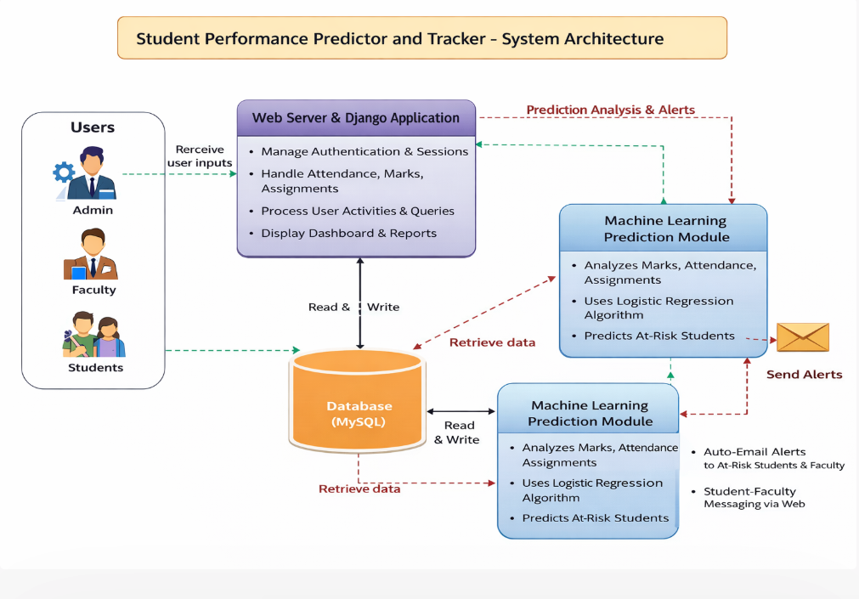

Figure 3.1: Project Architecture of Student Performance Predictor and Tracker

DESCRIPTION

Input Data : The system collects student data such as marks, attendance, assignments, and participation from various sources within the institution.

Reading Data: The collected data is processed and organized using tools like Python libraries (Pandas, NumPy) to prepare it for analysis.

Feature Extraction : Important features such as attendance percentage, academic scores, and participation levels are extracted to better understand student performance.

Prediction Model: Machine learning algorithms such as Decision Trees or Random Forest are applied to analyze the data and predict student performance.

Performance Analysis: The system evaluates patterns and trends in student data to identify strengths and weaknesses

Classification Layer : Students are classified into categories such as high-performing, average, or at-risk based on prediction results.

Training and Evaluation : The model is trained using historical student data and evaluated for accuracy to ensure reliable predictions.

Visualization: The system generates graphs, reports, and dashboards to display student performance in an easy-to-understand format

Feedback : Feedback from teachers and updated student data are continuously added to improve the model’s accuracy and overall system performance.

DATA FLOW DIAGRAM
A Data Flow Diagram (DFD) is a graphical representation that illustrates how data flows within a system, showcasing its processes, data stores, and external entities. It is a vital tool in system analysis and design, helping stakeholders visualize the movement of information, identify inefficiencies, and optimize workflows.
A Data Flow Diagram comprises Four primary elements:
    - External Entities: Represent sources or destinations of data outside the system.
    - Processes: Indicate transformations or operations performed on data.
    - Data Flows: Depict the movement of data between components.
    - Data Stores: Represent where data is stored within the system.

These components are represented using standardized symbols, such as circles for processes, arrows for data flows, rectangles for external entities, and open-ended rectangles for data stores.

Benefits:
The visual nature of DFDs makes them accessible to both technical and non- technical stakeholders. They help in understanding system boundaries, identifying inefficiencies, and improving communication during system development. Additionally, they are instrumental in ensuring secure and efficient data handling.

Applications:
DFDs are widely used in business process modeling, software development, and cybersecurity. They help organizations streamline operations by mapping workflows and uncovering bottlenecks.

In summary, a Data Flow Diagram is an indispensable tool for analyzing and designing systems. Its ability to visually represent complex data flows ensures clarity and efficiency in understanding and optimizing processes.

Levels of DFD:
DFDs are structured hierarchically:

- Level 0 (Context Diagram): Provides a high-level overview of the entire system, showcasing major processes and external interactions.

- Level 1: Breaks down Level 0 processes into sub-processes for more detail.
- Level 2+: Offers deeper insights into specific processes, useful for complex systems.

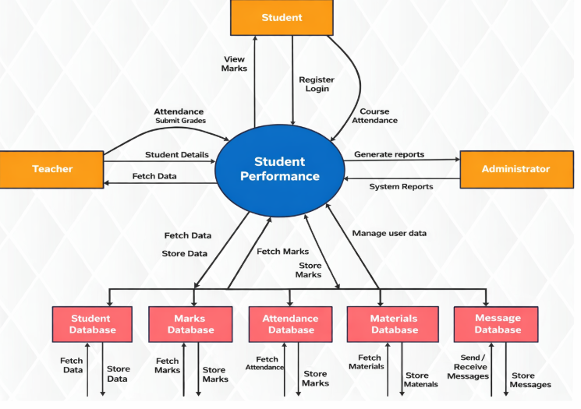

Figure 3.2: Dataflow Diagram of Student performance Predictor and Tracker

4.IMPLEMENTATION

4. IMPLEMENTATION
The Student Performance Predictor and Tracker is implemented as a web-based application using Python and machine learning libraries. Initially, student data such as marks, attendance, and assignments is collected and stored in a MySQL database. The data is then preprocessed using tools like Pandas and NumPy to clean and organize it. Machine learning algorithms are applied to analyze the data and predict student performance. The system includes a backend for processing and a frontend interface for Admin, Teachers, and Students to interact with the system. Finally, the results are displayed through reports and dashboards, allowing users to easily monitor and improve student performance.

4.1 ALGORITHMS USED

1. Decision Tree Algorithm

The Decision Tree algorithm is used to classify student performance based on various factors such as marks, attendance, and assignments. It works in a tree-like structure where each node represents a decision and each branch represents an outcome. In this project, it helps in clearly identifying whether a student is performing well or is at risk based on predefined conditions. The simplicity of this algorithm makes it easy for teachers to understand the decision process and take appropriate actions for student improvement.

Advantages:

Easy to understand and interpret

Works well with both numerical and categorical data

Helps in clear decision-making for student classification

Requires less data preprocessing

Disadvantages:

Can easily overfit the data

Less accurate compared to advanced algorithms

Sensitive to small changes in data

2. Random Forest Algorithm

Random Forest is an improved version of the Decision Tree algorithm that uses multiple decision trees to make predictions. In this project, it plays a key role in increasing prediction accuracy by combining results from different trees. This helps in reducing errors and providing more reliable

predictions about student performance. It is especially useful when dealing with large datasets that include multiple student-related factors.

Advantages:

High accuracy and better prediction results

Reduces overfitting by using multiple trees

Works well with large datasets

Handles missing data effectively

Disadvantages:

More complex than Decision Tree

Takes more time for training

Requires more computational resources

3. Logistic Regression

Logistic Regression is used for classification tasks such as predicting whether a student will pass or fail. In this project, it analyzes input data like attendance percentage, internal marks, and assignment scores to calculate the probability of student success. Based on this probability, the system can identify students who are likely to underperform and require additional attention from teachers.

Advantages:

Simple and easy to implement

Works well for binary classification (pass/fail)

Provides probability-based results

Requires less computational power

Disadvantages:

Not suitable for complex data patterns

Limited to linear relationships

Accuracy may be lower compared to advanced models

4. Support Vector Machine (SVM)

Support Vector Machine is used to classify students into different performance categories by finding the best boundary between data points. In this project, it helps in separating students into groups such as high-performing, average, and at-risk. It is effective when the data is complex and contains multiple features, improving the overall accuracy of the prediction system.

Advantages:

Works well with complex and high-dimensional data

Provides high accuracy

Effective in classification tasks

Handles small datasets efficiently

Disadvantages:

Difficult to understand and implement

Equires more processing time

Not suitable for very large datasets

5. Naive Bayes Algorithm

Naive Bayes is a simple and fast algorithm based on probability theory. In this project, it is used for quick prediction of student performance based on available data. It works efficiently even when the dataset is small and provides fast results, making it useful for initial analysis and real-time predictions in the system.

Advantages:

Simple and fast algorithm

Works well with small datasets

Requires less training time

Good for quick predictions

Disadvantages:

Assumes features are independent (not always true)

Lower accuracy compared to other algorithms

May not handle complex relationships well

4.2 SAMPLE CODE

from django.shortcuts import render
from django.http import HttpResponse
import pymysql
from datetime import datetime

# ---------- DB ----------
def db():
return pymysql.connect(host='127.0.0.1', user='root', password='', database='studentapp')

# ---------- LOGIN ----------
def StudentLogin(request): return render(request,'StudentLogin.html')
def FacultyLogin(request): return render(request,'FacultyLogin.html')
def AdminLogin(request): return render(request,'AdminLogin.html')

def StudentLoginAction(request):
u,p = request.POST['t1'], request.POST['t2']
c=db().cursor()
c.execute("SELECT * FROM student WHERE username=%s AND password=%s",(u,p))
if c.fetchone():
request.session['uname']=u
return render(request,'StudentScreen.html',{'data':'Welcome '+u})
return render(request,'StudentLogin.html',{'data':'Login Failed'})

def FacultyLoginAction(request):
u,p = request.POST['t1'], request.POST['t2']
c=db().cursor()
c.execute("SELECT * FROM faculty WHERE username=%s AND password=%s",(u,p))
if c.fetchone():
request.session['uname']=u
return render(request,'FacultyScreen.html',{'data':'Welcome '+u})
return render(request,'FacultyLogin.html',{'data':'Login Failed'})

def AdminLoginAction(request):

if request.POST['t1']=='admin' and request.POST['t2']=='admin':
return render(request,'AdminScreen.html',{'data':'Welcome Admin'})
return render(request,'AdminLogin.html',{'data':'Login Failed'})

# ---------- MARKS ----------
def ViewMarksAction(request):
u=request.session.get('uname')
c=db().cursor()
c.execute("SELECT subject_name,subject_marks FROM marks WHERE student_name=%s",(u,))
rows=c.fetchall()

total=sum(r[1] for r in rows)
avg=total/len(rows) if rows else 0

out="<table border=1><tr><th>Subject</th><th>Marks</th></tr>"
for r in rows:
out+=f"<tr><td>{r[0]}</td><td>{r[1]}</td></tr>"
out+=f"</table>Total:{total} Avg:{avg}"

return render(request,'StudentScreen.html',{'data':out})

def AddMarksAction(request):
u=request.session.get('uname')
d=(request.POST['sname'],u,request.POST['t1'],request.POST['t3'],
request.POST['t2'],request.POST['t4'],request.POST['t5'],datetime.now())
c=db().cursor()
c.execute("INSERT INTO marks VALUES(%s,%s,%s,%s,%s,%s,%s,%s)",d)
c.connection.commit()
return render(request,'FacultyScreen.html',{'data':'Marks Added'})

# ---------- MESSAGES ----------
def SendMessage(request):
u=request.session.get('uname')
d=(u,request.POST['sname'],request.POST['t1'],request.POST['t2'],datetime.now())

c=db().cursor()
c.execute("INSERT INTO messages VALUES(%s,%s,%s,%s,%s)",d)
c.connection.commit()
return render(request,'FacultyScreen.html',{'data':'Message Sent'})

def ViewMessages(request):
u=request.session.get('uname')
c=db().cursor()
c.execute("SELECT sender_name,subject,message FROM messages WHERE receiver_name=%s",(u,))
rows=c.fetchall()

out="<table border=1>"
for r in rows:
out+=f"<tr><td>{r[0]}</td><td>{r[1]}</td><td>{r[2]}</td></tr>"
out+="</table>"

return render(request,'StudentScreen.html',{'data':out})

# ---------- ATTENDANCE ----------
def AddAttendanceAction(request):
u=request.session.get('uname')
students=request.POST.getlist('t1')
today=datetime.now().strftime("%Y-%m-%d")

c=db().cursor()
for s in students:
c.execute("INSERT INTO student_attendance VALUES(%s,%s,%s)",(s,u,today))

c.execute("SELECT total_classes,attended_classes FROM attendance_summary WHERE student_name=%s",(s,))
r=c.fetchone()

c.execute("UPDATE attendance_summary SET total_classes=%s,attended_classes=%s WHERE student_name=%s",
(r[0]+1,r[1]+1,s))
else:
c.execute("INSERT INTO attendance_summary VALUES(%s,%s,%s)",(s,1,1))

c.connection.commit()
return render(request,'FacultyScreen.html',{'data':'Attendance Done'})

# ---------- ASSIGNMENTS ----------
def CreateAssignmentAction(request):
u=request.session.get('uname')
d=(u,request.POST['t1'],request.POST['t2'],request.POST['t3'],
request.POST['t4'],request.POST['t5'],request.POST['t6'])
c=db().cursor()
c.execute("INSERT INTO assignments VALUES(%s,%s,%s,%s,%s,%s,%s)",d)
c.connection.commit()
return render(request,'FacultyScreen.html',{'data':'Assignment Created'})

def ViewAssignments(request):
c=db().cursor()
c.execute("SELECT * FROM assignments")
rows=c.fetchall()

out="<table border=1>"
for r in rows:
out+=f"<tr><td>{r[0]}</td><td>{r[1]}</td><td>{r[2]}</td><td>{r[4]}</td></tr>"
out+="</table>"

return render(request,'StudentScreen.html',{'data':out})

# ---------- MATERIALS ----------
def UploadMaterialAction(request):
u=request.session.get('uname')

file=request.FILES['t3']
name=file.name

open("PerformanceApp/static/files/"+name,"wb").write(file.read())

c=db().cursor()
c.execute("INSERT INTO uploadmaterial VALUES(%s,%s,%s,%s,%s)",
(u,request.POST['t1'],request.POST['t2'],name,datetime.now()))
c.connection.commit()

return render(request,'FacultyScreen.html',{'data':'Uploaded'})

def DownloadMaterialAction(request):
name=request.GET.get('name')
with open("PerformanceApp/static/files/"+name,"rb") as f:
res=HttpResponse(f.read(),content_type='application/force-download')
res['Content-Disposition']='attachment; filename='+name
return res

# ---------- STUDENT ----------
def AddStudentAction(request):
d=(request.POST['t1'],request.POST['t2'],request.POST['t3'],
request.POST['t4'],request.POST['t5'],request.POST['t6'],
request.POST['t7'],request.POST['t8'])
c=db().cursor()
c.execute("INSERT INTO student VALUES(%s,%s,%s,%s,%s,%s,%s,%s)",d)
c.connection.commit()
return render(request,'AdminScreen.html',{'data':'Student Added'})

# ---------- BASIC ----------
def index(request): return render(request,'index.html')

5. RESULTS & DISCUSSION

5. RESULTS & DISCUSSION

The following screenshots showcase the results of our project, highlighting key features and functionalities. These visual representations provide a clear overview of how the system performs under various conditions, demonstrating its effectiveness and user interface. The screenshots serve as a visual aid to support the project's technical and operational achievements.

5.1 GUI/Main Interface :

In below screen, the main interface of the system is displayed. The user can access different modules such as Admin, Teacher, and Student operations from this dashboard

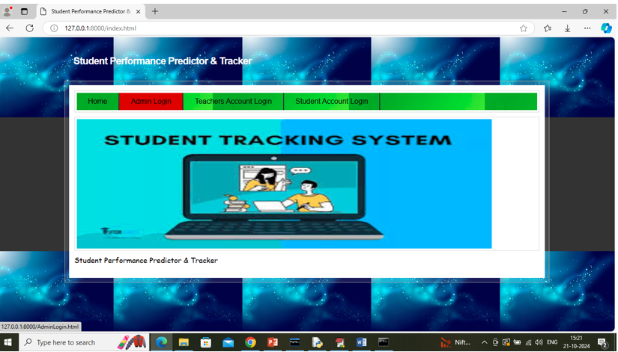

Figure 5.1 : GUI/Main Interface of Student Performance Predictor and Tracker.

Loaded Sample Image :

The selected image is successfully loaded into the system for processing.
It is used as input for analysis and further prediction.

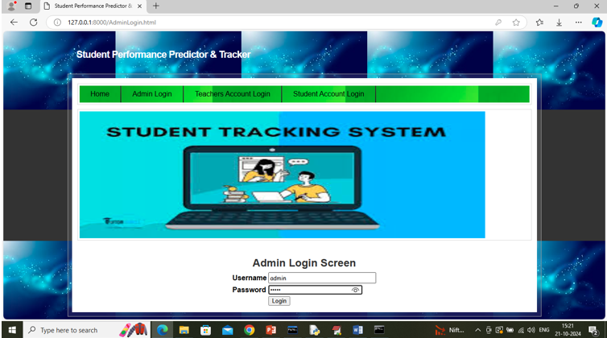

Figure 5.2 : Loaded sample image of Student Performance Predictor and Tracker.

Admin Login:

Admin enters username and password to log in. The system verifies the credentials for authentication. Only authorized users can access the admin panel.
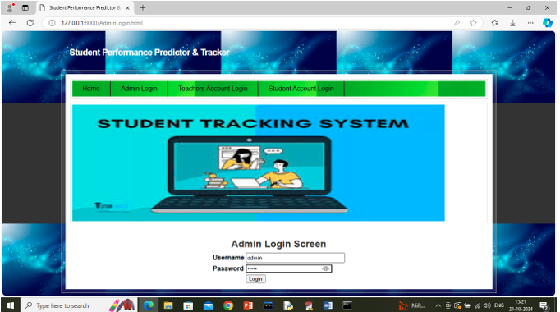
Figure 5.3 : Admin Login of Student Performance Predictor and Tracker

Add Teacher Details :

Admin enters teacher details into the system.Information like name and contact is stored.
This helps in managing teacher records efficiently..

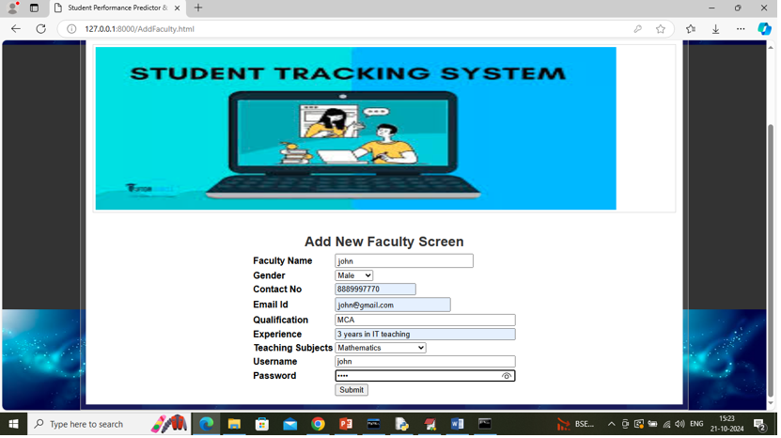

Figure 5.4 : Teacher Details of Student Performance Predictor and Tracker

Add Student Details:

Admin adds student personal and academic data.The details are stored in the database securely.This data is used for tracking and prediction.

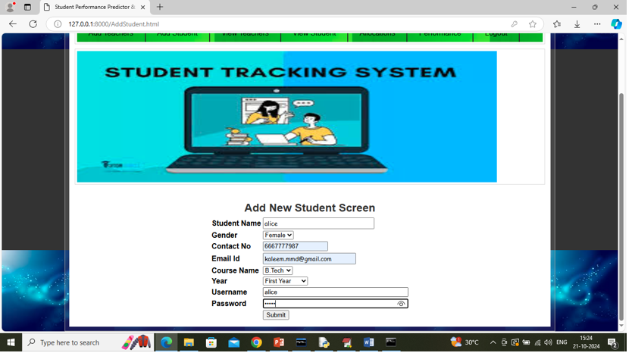

Figure 5.5 : Student Details of Student Performance Predictor and Tracker

Performance:

The system analyzes student data to evaluate overall performance.It uses factors like marks, attendance, and assignments for accurate results.

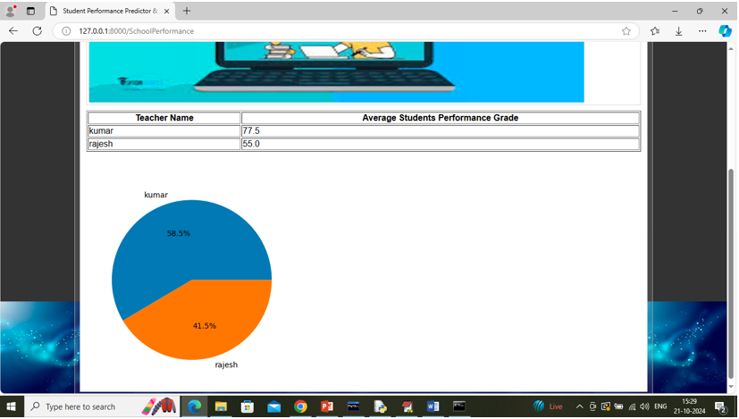

Figure 5.6 : Performance of Student Performance Predictor and Tracker

Teacher Login:

Teacher logs into the system using credentials. The system validates login information. Provides secure access to teacher dashboard.

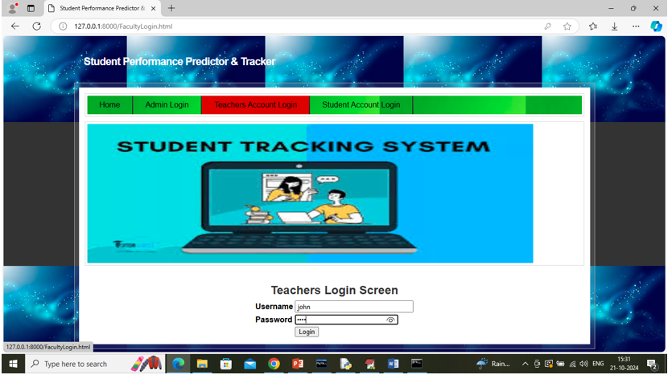

Figure 5.7 Teacher Login of Student Performance Predictor and Tracker

Add Attendance:

Teacher marks attendance of students.Attendance data is recorded and stored.Used for tracking student performance.

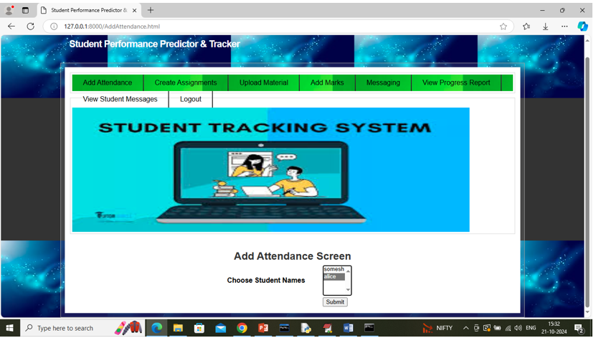

Figure 5.8 : Add Attendance of Student Performance Predictor and Tracker

Create Assignments :

Teacher creates assignments for students.Assignment details are saved in the system.Helps in evaluating student learning.

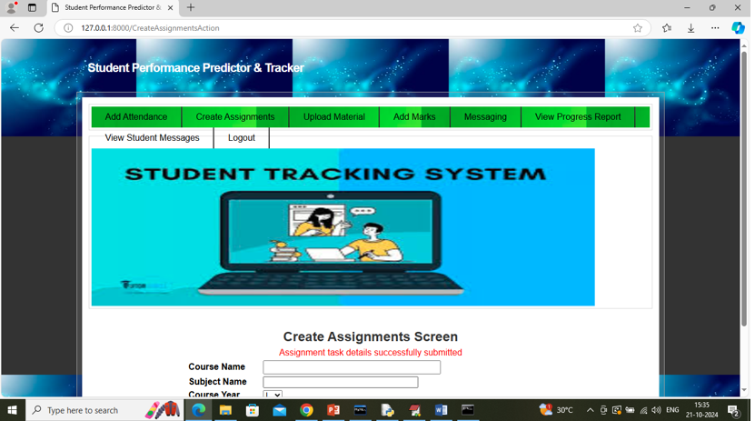

Figure 5.9 : Create Assignments of Student Performance Predictor and Tracker

Uploading Material:

Teacher uploads study resources for students.Materials are stored and made accessible.Students can use them for learning support.

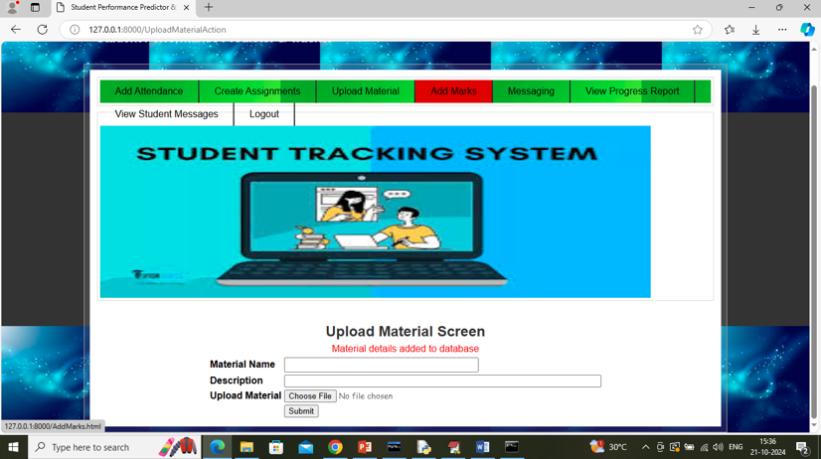

Figure 5.10 : Uploading Material of Student Performance Predictor and Tracker

  - Adding Marks

Teacher enters marks for each subject.Marks are stored in the system database.Used for performance analysis and prediction.

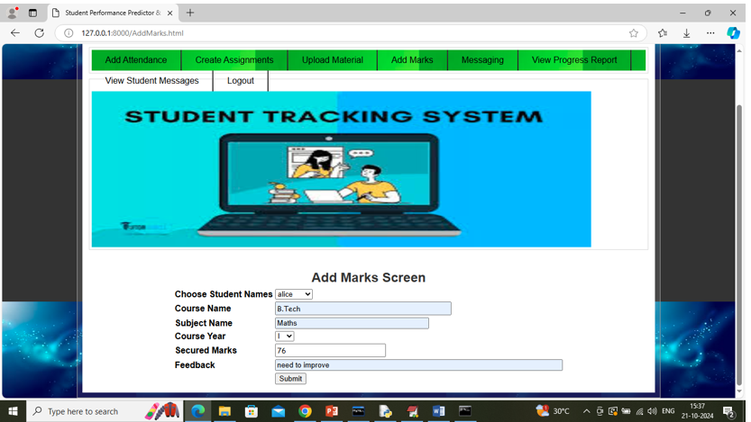

Figure 5.11 Adding Marks of Student Performance Predictor and Tracker

  - Student Login

Student enters login credentials to access system.The system verifies user authentication.Ensures secure access to student dashboard.

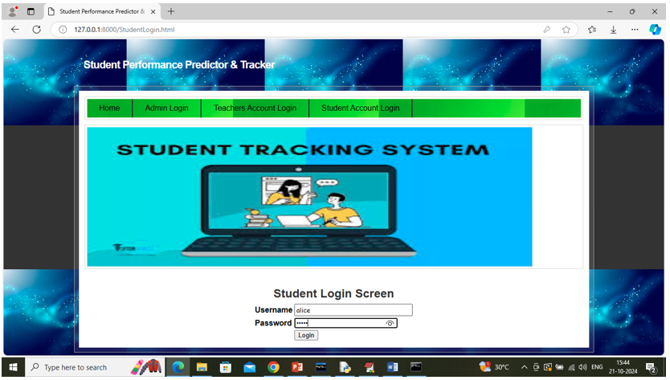

Figure 5.12 Adding Marks of Student Performance Predictor and Tracker

  - Download Material

Students can download study materials.Provides easy access to learning resources.Supports better understanding of subjects.

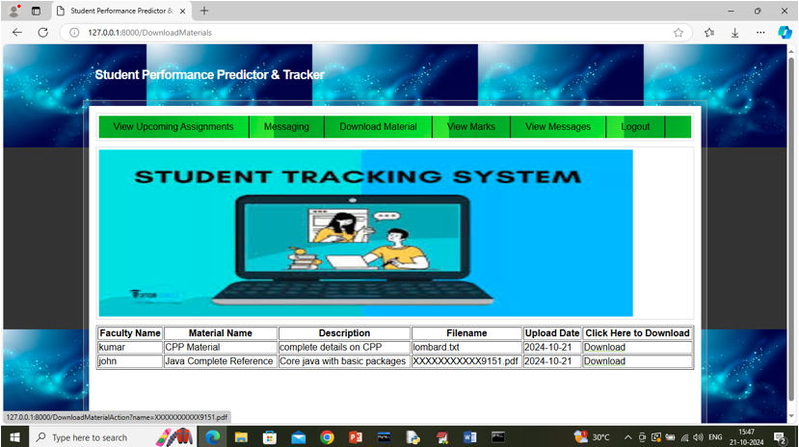

Figure 5.13 Adding Marks of Student Performance Predictor and Tracker

6.VALIDATION

6. VALIDATION

The Student Performance Predictor and Tracker system has been carefully tested and validated to ensure that it works correctly and provides accurate results. The validation process was carried out by checking each module of the system with different types of input data and verifying the outputs.During testing, valid and invalid inputs were given in modules such as login, student details, marks entry, and attendance. The system successfully accepted correct data and displayed appropriate error messages for incorrect or incomplete inputs. This confirms that input validation is working properly.The prediction functionality was also validated by using sample student data. The system was able to analyze the given data and generate meaningful predictions about student performance. The results were consistent and helped in identifying students who may require additional support.All modules such as Admin, Teacher, and Student dashboards were tested individually and together to ensure smooth integration. The system responded correctly in all cases without any major errors. Graphs and reports generated by the system were also verified and found to be accurate and easy to understand.Overall, the system has been successfully validated and meets the required objectives. It is reliable, user-friendly, and capable of assisting educators in monitoring and improving student performance effectively.

6.1 INTRODUCTION

First, the dataset containing student information such as marks, attendance, and academic records is collected and divided into training and testing sets, typically using an 80:20 ratio. The training data is used to train the machine learning model, while the testing data is used to evaluate how well the model performs on new and unseen data. To improve the reliability of the system, cross-validation techniques are applied, ensuring that the model is tested on different data samples. This helps in reducing overfitting and improves the overall accuracy of predictions.
The performance of the system is evaluated using various metrics such as accuracy, precision, and error analysis. The system analyzes student data and predicts their academic performance, helping to identify students who may require additional support. Different machine learning algorithms can be compared to determine the best-performing model. The results show that the proposed system provides reliable predictions and helps teachers make better decisions to improve student outcomes.

6.2 TEST CASES

TABLE 6.3.1 UPLOADING DATASET

Test case ID | Test case name | Purpose | Test Case | Output
1 | add student data | To store Student Information | Admin enters student details and submits the form | Student data successfully saved

TABLE 6.3.2 STUDENT PERFORMANCE PREDICTION

Test case ID | Test case  name | Purpose | Input | Output
1 | Prediction Test 1 | To check prediction for good performance | High marks, good attendance | Predicted as Good Performance
2 | Prediction Test 2 | To check prediction for poor performance | Low marks, low attendance | Predicted as Poor Performance

7.CONCLUSION & FUTURE ASPECTS

7. CONCLUSION & FUTURE ASPECTS
In conclusion, the project has successfully achieved its objectives, showcasing significant progress and outcomes. The implementation and execution phases were meticulously planned and executed, leading to substantial improvements and insights. Looking ahead, the future aspects of the project hold immense potential. Future developments will focus on expanding the scope, integrating new technologies, and enhancing sustainability. These advancements will not only strengthen the existing framework but also open new avenues for growth and innovation, ensuring the project remains relevant and impactful in the long term. This strategic approach will drive continuous improvement and success.

7.1 PROJECT CONCLUSION

The Student Performance Predictor provides an effective and data-driven approach to evaluating student success based on various influencing factors such as academic records, attendance, extracurricular involvement, and socio-economic conditions. By utilizing machine learning algorithms, this system enables educational institutions to identify at-risk students early and take proactive measures to improve their academic outcomes.

The predictive model enhances decision-making for educators and administrators by offering insights into student performance trends, helping in curriculum improvement and personalized learning strategies. Furthermore, integrating advanced techniques such as deep learning and sentiment analysis can enhance the model’s accuracy in the future.

Overall, this system has the potential to revolutionize the education sector by promoting data-driven strategies, reducing dropout rates, and improving overall student success. Future enhancements could include real-time monitoring, adaptive learning recommendations, and integration with AI-driven tutoring systems for better student engagement.

7.2 FUTURE ASPECTS

The Student Performance Predictor and Tracker system can be enhanced by integrating real-time data from student records such as attendance, marks, and online learning platforms. This will help in providing more accurate and up-to-date predictions. The use of advanced machine learning and deep learning techniques can further improve prediction accuracy by identifying complex patterns and relationships in student data. Expanding the dataset and improving data quality can also make the system more reliable and effective.
The system can be extended to provide personalized learning recommendations based on individual student performance, helping teachers adjust their teaching strategies. It can also generate automatic alerts to identify at-risk students, enabling timely intervention and support. In the future, the system can be developed as a mobile or cloud-based application for easy access by students, teachers, and parents. Adding features like student engagement analysis and ensuring fairness in predictions will further improve the overall performance and usefulness of the system.

8.BIBLIOGRAPHY

BIBLIOGRAPHY

REFERENCES

- Ahmed, W., Wani, M. A., Plawiak, P., Meshoul, S., & Hammad, M. (2025). Machine learning-based academic performance prediction with explainability. Scientific Reports, 15, 26879.
- Gul, M. N., Abbasi, W., & Wani, M. Y. (2025). Machine learning mechanism for predicting student performance. Journal of Electrical Systems and Information Technology, 12, 32.
- Wang, C., & Yao, S. (2025). Enhancing student dropout and academic success prediction using machine learning. ICCK Transactions on Educational Data Mining, 1(1), 36–43.
- Zhang, H., Ren, Y., Nurius, P. S., Mankoff, J., & Dey, A. K. (2025). Early prediction models for academic performance. arXiv preprint arXiv:2504.12236.
- Tiwari, M., & Jain, N. (2024). Student performance prediction using machine learning algorithms. ShodhKosh Journal, 5(6), 1112–1122.
- ang, B., Li, S., & Zhao, C. (2024). Predicting student performance using deep ensemble learning. Journal of Intelligence, 12(12), 124.
- Zhu, X. (2024). Prediction and analysis of university student performance using machine learning. Academic Journal of Computing & Information Science, 7(8), 79–86.
- Al-Sarem, M., Saeed, F., Al-Hadhrami, T., & Boulila, W. (2023). Intelligent system for predicting student performance using ML algorithms. Baghdad Science Journal, 21(12), 3877–3891.
- Waheed, H., Hassan, S., Aljohani, N., & Hardman, J. (2022). Predicting student performance using educational data mining. Computers & Education, 168, 104–115.

GITHUB LINK

https://github.com/akshayamogili06-ship-it/student-performance-and-tracker

